**IBM CLOUD CLI**

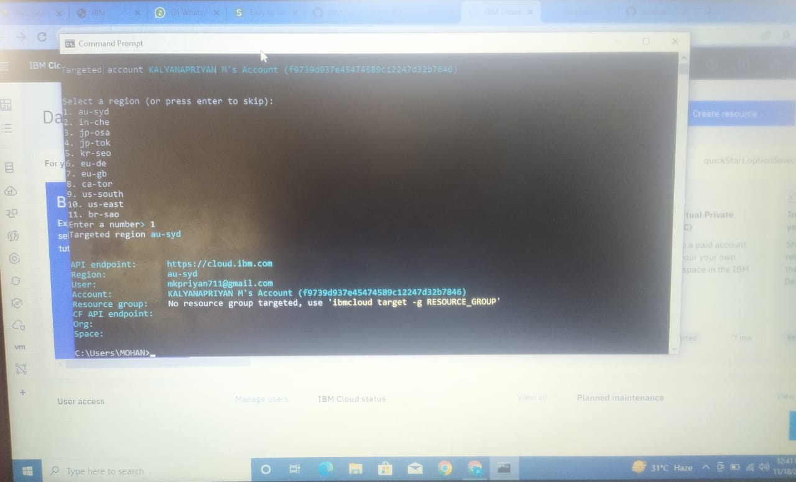Team ID : PNT2022TMID16512